**ASSIGNMENT 1**

| **BATCH NUMBER** | PNT2022TMID04977 |
| --- | --- |
| **STUDENT NAME** | ISWARYA V |
| **REGISTER NUMBER** | 921319104067 |

**Question-1:**

**Create a registration page in html with username, email, and phone number and by using POST method display it in the next html page.**

**index.html**

<!DOCTYPE html>

<html>

<head>

<meta charset="utf-8">

<meta name="viewport" content="width=device-width, initial scale=1">

<title>Registration</title>

<link rel="stylesheet" href="{{

url_for('static',filename='styles/index.css') }}">

</head>

<body>

<center>

<br><br>

<h1>Registration</h1><br>

<form action="{{ url_for('result') }}" method="post">

<table>

<tr>

<td>

<label>Name</label>

</td>

<td>

: <input type="text" class="name-input

name mb-3" id="name" name="name">

</td>

</tr>

<tr>

<td>

<label>Email</label>

</td>

<td>

: <input type="email" class="name

input name mb-3" id="email" name="email">

</td>

</tr>

<tr>

<td>

<label>Mobile</label>

</td>

<td>

: <input type="number" class="name

input name mb-3" id="mobile" name="mobile">

</td>

</tr>

</table>

<br><br>

<input class="btn btn-outline-primary" type="submit" value="Submit">

</form>

</center>

</body>

</html>

**result.html**

<!DOCTYPE html>

<html>

<head>

<meta charset="utf-8">

<meta name="viewport" content="width=device-width, initial scale=1">

<title>Profile</title>

<link rel="stylesheet" href="{{

url_for('static',filename='styles/index.css') }}">

</head>

<body>

<center>

<br><br>

<h1>Welcome !!!</h1>

<br>

<form action="{{ url_for('result') }}" method="post"> <table>

<tr>

<h3>Name : {{ name }}<br></h3>

</tr>

<tr>

<h3>Email : {{ email }}<br></h3>

</tr>

<tr>

<h3>Mobile : {{ mobile }}<br></h3>

</tr>

</table>

<br><br>

</form>

</center>

</body>

</html>

**app.py**

from flask import *;

import os

app = Flask(__name__)

@app.route('/', methods=['GET', 'POST'])

def home():

if request.method == 'POST':

name = request.form["name"]

email= request.form["email"]

mobile = request.form["mobile"]

return redirect(url_for('result', name=name, email=email, mobile=mobile))

return render_template('index.html')

@app.route("/result", methods=['GET', 'POST'])

def result():

name = request.form.get('name')

email= request.form.get('email')

mobile = request.form.get('mobile')

return render_template('result.html', name=name, email=email, mobile=mobile)

if __name__ == "__main__":

app.run(debug=True, port=2807)

**OUTPUT:**

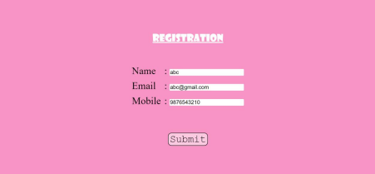

**Question-2:**

**Develop a Flask program which should contain at least 5 packages used from pypi.org**

*#1. NUMPY*

import numpy as np

arr = np.array([[-1, 2, 0, 4],

[4, -0.5, 6, 0],

[2.6, 0, 7, 8],

[3, -7, 4, 2.0]])

print("Initial Array: ")

print(arr)

Initial Array:

[[-1. 2. 0. 4. ]

[ 4. -0.5 6. 0. ]

[ 2.6 0. 7. 8. ]

[ 3. -7. 4. 2. ]]

*#2. PANDAS*

import pandas as pd

s1 = pd.Series([1, 3, 4, 5, 6, 2, 9])

s2 = pd.Series([1.1, 3.5, 4.7, 5.8, 2.9, 9.3])

s3 = pd.Series(['a', 'b', 'c', 'd', 'e'])

Data ={'first':s1, 'second':s2, 'third':s3}

df = pd.read_csv('/content/sample_data/ds_salaries.csv') print(df)

Unnamed: 0 work_year experience_level employment_type \ 0 0 2020 MI FT 1 1 2020 SE FT 2 2 2020 SE FT 3 3 2020 MI FT 4 4 2020 SE FT .. ... ... ... ... 602 602 2022 SE FT 603 603 2022 SE FT 604 604 2022 SE FT 605 605 2022 SE FT 606 606 2022 MI FT

job_title salary salary_currency salary_in_usd \

0 Data Scientist 70000 EUR 79833 1 Machine Learning Scientist 260000 USD 260000 2 Big Data Engineer 85000 GBP 109024

3 Product Data Analyst 20000 USD 20000 4 Machine Learning Engineer 150000 USD 150000 .. ... ... ... ... 602 Data Engineer 154000 USD 154000 603 Data Engineer 126000 USD 126000 604 Data Analyst 129000 USD 129000 605 Data Analyst 150000 USD 150000 606 AI Scientist 200000 USD 200000

employee_residence remote_ratio company_location company_size 0 DE 0 DE L 1 JP 0 JP S 2 GB 50 GB M 3 HN 0 HN S 4 US 50 US L .. ... ... ... ... 602 US 100 US M 603 US 100 US M 604 US 0 US M 605 US 100 US M 606 IN 100 US L

[607 rows x 12 columns]

*#3. SEABORN*

import seaborn as sns

sns.pairplot(df,hue="salary",height=3)

<seaborn.axisgrid.PairGrid at 0x7f32024d5650>

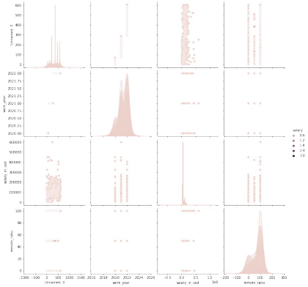

*#4. TENSORFLOW*

import tensorflow as tf

mnist = tf.keras.datasets.mnist

(x_train, y_train), (x_test, y_test) = mnist.load_data() x_train, x_test = x_train / 255.0, x_test / 255.0

model = tf.keras.models.Sequential([

tf.keras.layers.Flatten(input_shape=(28, 28)),

tf.keras.layers.Dense(128, activation='relu'),

tf.keras.layers.Dropout(0.2),

tf.keras.layers.Dense(10)

])

*#5. PYTZ*

from pytz import timezone

from datetime import datetime

format = "%Y-%m-%d %H:%M:%S %Z%z"

now_utc = datetime.now(timezone('UTC'))

print(now_utc.strftime(format))

now_asia = now_utc.astimezone(timezone('Asia/Kolkata')) print(now_asia.strftime(format))

2022-10-07 16:36:09 UTC+0000

2022-10-07 22:06:09 IST+0530